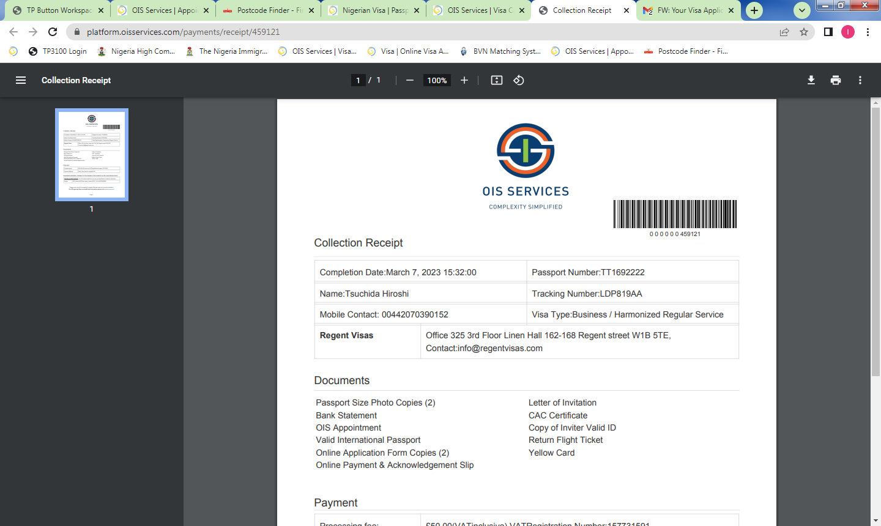
Spouse of GO Visa – R4B
R4B - Spouse of Employed Expatriate (Government Official) Visa is issued to spouse of Expatriate employed by Government as Government Official in Nigeria

Please read this checklist and Important Information in full before you start completing the application form.
Tick when complete

1 | APPOINTMENT SLIP:  OIS Appointment booking for each applicant. This can only be done after completing numbers 4 and 5 on this checklist and you have all the documents on this checklist with you. Please only book if it is within 45 days of your travel date.  You are advised not to apply for a Multiple entry visa, if it is your first visit or trip to Nigeria as you will only be issued with a single entry visa.  https://apt.oisservices.com
2 | TRAVEL DOCUMENT:  Passport/Travel Document a minimum of 6 months validity at the time of travelling to and from Nigeria, with two blank facing pages.  Passport/Travel Document will be held by the mission until a decision has been made.
3 | PASSPORT SIZE PHOTOS:  Two recent UK passport sized photographs, taken no more than 2 weeks before submission, with applicant’s full name written on the back. (Photographs older than 1 month are not acceptable).
4 | ONLINE APPLICATION FORM:  Completed application form filled in and paid for online at  https://visa.immigration.gov.ng/  Once completed this must be printed out, in portrait.
5 | ONLINE PAYMENT AND ACKNOWLEDGMENT RECEIPTS:  Valid Payment and Acknowledgement slips, available once online payment has been complete – Print both from https://portal.immigration.gov.ng/visa/OnlineQueryStatus
6 | LETTER OF REQUEST:  A Typed letter of request addressed to the Nigeria High Commission London, from the employer that you will be working for, requesting the STR Visa for the applicant, this must contain the applicant’s full name and It must state that the employer takes full immigration responsibilities. This must be signed and dated by a senior. (4 Copies)
7 | TYPED LETTER FROM YOUR SPOUSE:  A formal typed letter, addressed to the Nigeria high commission London, from your spouse, stating the purpose of the visa and It must include the address where the applicant is staying. It must also be dated and signed by the spouse.(4 Copies)
8 | SPECIAL DELIVERY ENVELOPE:  All applicants must provide a 1kg/A3 pre-paid special delivery envelope to return the passport. This can be purchased from the Post office before submission.
9 | DOCUMENT HANDLING AND FILING FEE:  £30 payment to be made by bank card at the centre.
10 | EXPRESS SERVICE (OPTIONAL):  £100 Postal order for express service made payable to NIGERIA HIGH COMMISSION. Postal order to be purchased from the post office before coming to our centre.

IMPORTANT INFORMATION

- PROCESSING TIMES-
Regular Service- Minimum of 10 Working Days
Express Service- Minimum of 6 Working Days

- FEE BREAKDOWN-
1) Online fee- Please note that the online payment amount varies depending on the passport you hold

2) OIS Service charge- £20 payable by bank card at the centre
3) Optional-Express Service Charge - Additional £70 Postal order

- All visa applicants are to submit their application in person, as you are now required to capture biometrics as a part of the visa requirements.

- Applications submitted after 12.30 PM will be treated as next day applications.

- All documents required on the checklist must be shown and approved before we process your application.

- Documents which ARE NOT IN ENGLISH must be provided with a certified translated version. Please provide the original and a copy.

- Documents which do not reflect your current name on your passport must be provided with your change of name deed poll or marriage certificate if your last name was changed. (Original and copy)

- Any Necessary documents print/photocopy in our Centre, will incur an additional charge of £10

- All Documents and Letter must be formal. They should be typed, printed in portrait, addressed to the Nigerian High Commission London, signed and dated.
- NIGERIAN DUAL NATIONALS- Provide a copy of your valid or expired Nigeria passport data page.

- EU NATIONALS- A copy of your UK Residency or EU Settlement Scheme (EUSS), please bring along the original for those with the original ID or Document.

- REPUBLIC OF IRELAND PASSPORT HOLDERS- Two most recent utility bills in the applicant’s name or Full Tenancy Agreement or Current Mortgage statement. (BANK STATEMENT/DRIVING LICENSE ARE NOT ACCEPTED AS UTILITY BILLS)

- OTHER NATIONALS- UK Residency card or visa residency stamped on passport, this must be valid for a minimum of 6 months at time of coming to the centre and travelling to and from Nigeria. Please bring the original and a copy.

- FOR UK DUAL NATIONALS –We do not accept a UK passport as proof of residency when applying with a foreign passport. If you do not have proof of residency/citizenship other than your UK passport, Please apply with your UK passport instead.

- UK TRAVEL DOCUMENT HOLDERS – when selecting your country of origin, please select UNITED KINGDOM.

Please check our opening hours to avoid delays and for any additional information please email us at info@oisservices.com or visit our website www.oisservices.com

